**Steps to Install Visual Studio Code on Windows**

**Step 1:** Visit the [**Official Website**](https://code.visualstudio.com/docs/?dv=win) of the **Visual Studio Code** using any web browser like [Google Chrome](https://www.geeksforgeeks.org/how-to-browse-in-google-chrome-browser/), [Microsoft Edge](https://www.geeksforgeeks.org/tools-and-features-in-microsoft-edge-browser/), etc.

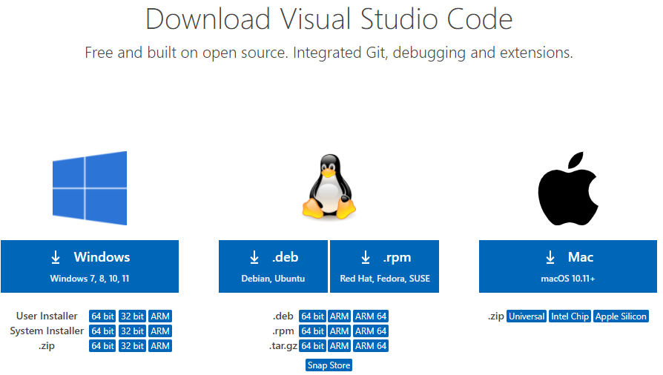

**Step 2:** Press the “**Download for Windows**” button on the website to start the download of the Visual Studio Code Application.



**Step 3:** When the download finishes, then the **Visual Studio Code Icon** appears in the downloads folder.

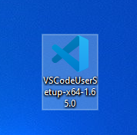

**Step 4:** Click on the **Installer** icon to start the installation process of the Visual Studio Code.

**Step 5:** After the Installer opens, it will ask you to accept the terms and conditions of the Visual Studio Code. Click on **I accept the agreement**and then clickthe **Next**button.

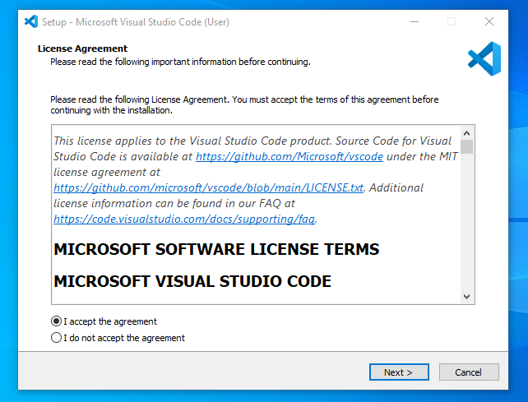

**Step 6:** Choose the location data for running the Visual Studio Code. It will then ask you to browse the location. Then click on the **Next** button.

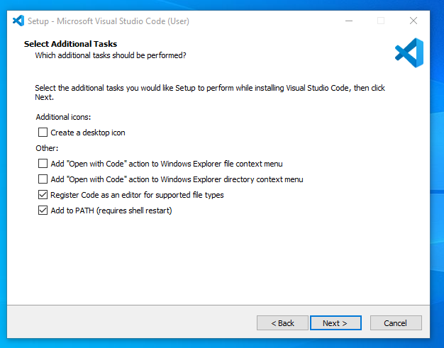

**Step 7:** Then it will ask to begin the installation setup. Click on the**Install** button.

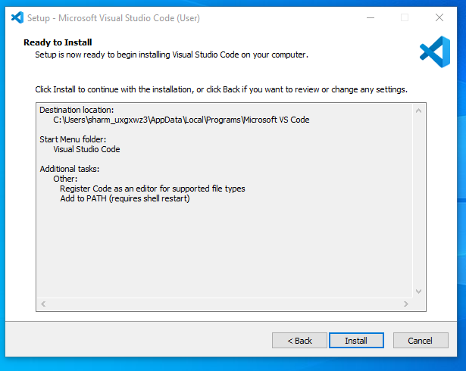

**Step 8:** After clicking on Install, it will take about 1 minute to install the Visual Studio Code on your device.

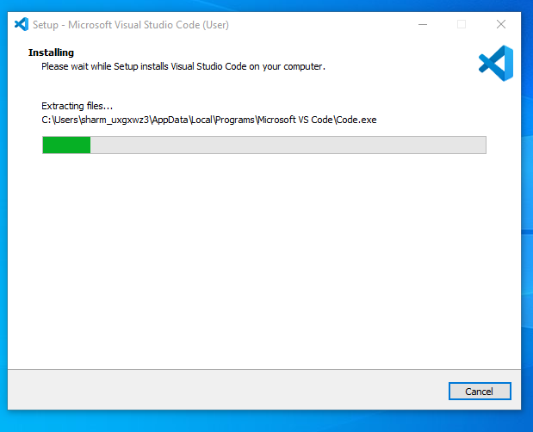

**Step 9:**After the Installation setup for Visual Studio Code is finished, it will show a window like this below. Tick the “**Launch Visual Studio Code**” checkbox and then click **Next**.

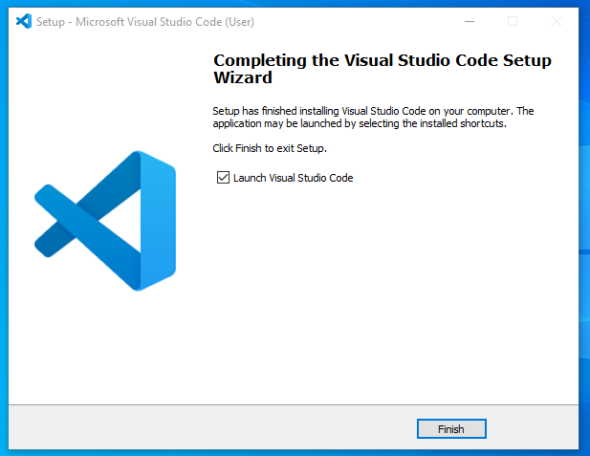

**Step 10:** After the previous step, the **Visual Studio Code window** opens successfully. Now you can create a new file in the Visual Studio Code window and choose a language of yours to begin your programming journey!

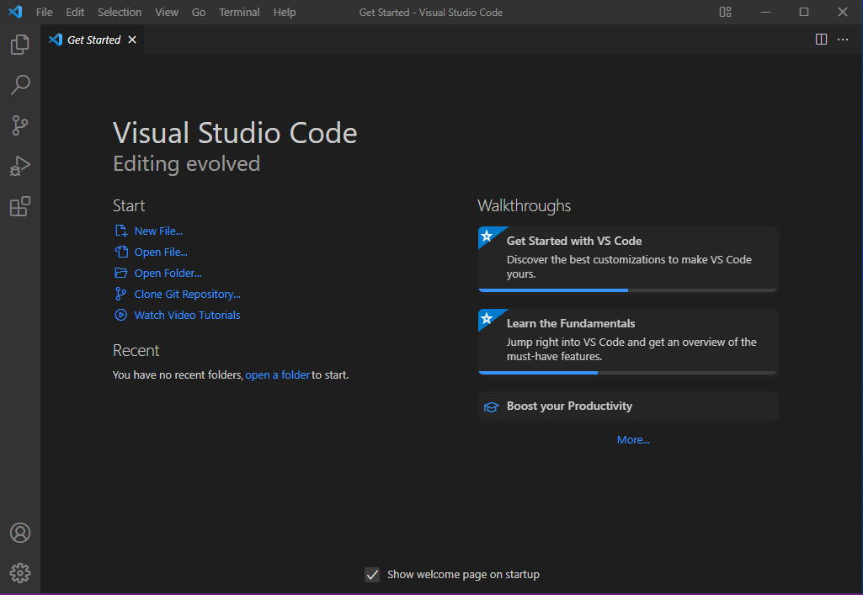

So this is how we successfully installed**Visual Studio Code** on our Windows system.